QUANTUM COMPUTING FOR ENHANCED COMPUTATIONAL INTELLIGENCE IN BUSINESS DECISION-MAKING
Souraja Mandal, Lakshmi Sameera, Mr Mahesh Kumar
Department of Computer Science Engineering (CSE), KLH University, Bachupally, Hyderabad, India
Quantum Computing (24CS3207) | Academic Year 2026–2027 | Guide: Mr. Mahesh Kumar
Abstract—Quantum computing is beginning to influence the way businesses view intelligence and decision-making. Classical computing has difficulty coping with the issues of data, complex optimisation problems and rapidly changing situations. However, quantum computing operates under an entirely different paradigm utilising principles such as superposition, entanglement and quantum parallelism. In doing so, it offers to solve problems in a way that cannot be done through classical computing. When used alongside the power of intelligence, machine learning and optimisation algorithms, quantum computing is capable of offering rapid analysis, accurate forecasts and better decisions. This paper will investigate the application of quantum computing in such areas as forecasting, risk management, optimisation of the supply chain, allocation of resources and strategic planning. Even though there is a lot of potential, problems like quantum hardware, noise, scaling issues, high costs and not enough experts are still big problems. The study says that combining quantum computing with intelligence can create new chances for solving complex business problems and making better data-based decision-making systems.
Index Terms—Quantum Computing, Computational Intelligence, Business Decision-Making, Quantum Machine Learning, Optimisation
Project Website: Open Project Website
I. INTRODUCTION
Modern organisations increasingly rely on data-driven decisions that involve forecasting, allocating resources, assessing risk, planning logistics, understanding customer behaviour and shaping strategy. The size and complexity of these tasks can grow rapidly as more variables, constraints, scenarios and possible decisions appear. Classical intelligence and machine-learning systems remain the primary tools for business analytics. Yet some optimisation, simulation and estimation problems become computationally expensive as problem size increases. Quantum computing offers a computational model based on quantum states and operations, creating the possibility of new approaches for selected classes of difficult problems.
The goal of this paper is not to claim that quantum computers have already replaced business analytics. Instead, the study examines how quantum computing can be integrated with intelligence in a hybrid architecture. In such an architecture, classical systems continue to perform tasks for which they're effective while quantum algorithms are introduced where their structure may provide a useful advantage or a new optimisation strategy. This approach is especially relevant in the noisy intermediate-scale quantum era, where hardware is limited and hybrid algorithms are widely studied.
Computational intelligence, in this paper, refers to AI, ML, optimisation, predictive analytics and related data-driven methods. Quantum machine learning explores how quantum circuits can participate in learning workflows, including feature representations, quantum kernels and variational quantum circuits. Quantum optimisation methods, including the Quantum Approximate Optimisation Algorithm, are relevant to business problems that involve decisions and constraints. These methods can help solve problems where traditional approaches struggle.
The proposed framework follows a project workflow described in the project abstract: data collection, data preprocessing, feature selection and encoding, choosing AI/ML models and quantum-processing algorithms, making predictions and optimisations, providing business decisions and recommendations, and collecting feedback for model improvement. This framework is built to connect quantum processing with real-world business results. It does not treat the quantum circuit as an experiment but as part of a larger decision-making process.
I-A. Problem Statement
Business decision-making often involves dealing with data, conflicting goals, limited resources, and constantly changing conditions. For example, a portfolio manager may need to balance expected return against risk. A supply-chain planner might try to improve delivery performance while keeping inventory costs low. A company may have to decide how to divide a budget among projects. These situations are typically optimisation problems where the number of choices grows quickly. Predictive tasks can also be complicated by a number of features and intricate relationships between them. The main problem this paper focuses on is understanding how quantum computing can fit into computational-intelligence systems to support both prediction and optimisation. At the same time, it must keep the advantages of classical computing.
I-B. Objectives
1) Explain what role quantum computing plays in intelligence and business analytics.
2) Describe a classical workflow that supports business decision-making.
3) Look into quantum machine learning and variational quantum algorithms as parts of systems.
4) Study applications such as forecasting, risk management, supply-chain optimization, resource allocation and strategic planning.
5) Identify benefits, limitations, challenges in implementation and evaluation criteria, for quantum-enhanced decision systems.
II. LITERATURE SURVEY
Quantum computing has increasingly been studied as a complementary technology for artificial intelligence, optimisation, finance, and business analytics. There are no indications from existing literature about replacing classical computation with quantum computing; on the contrary, there are recommendations to utilise the concept of hybrid computing when classical computers are responsible for data preparation and optimisation, and quantum circuits compute particular operations only. Such an approach fits the architectural framework proposed in this project, which involves integration of classical AI/ML, quantum computing module, and business decision support module into one workflow.
The concept of quantum machine learning was introduced by Biamonte et al., who provided a survey of the field of quantum information processing and machine learning techniques. The survey included discussion of quantum algorithms and learning models and revealed practical restrictions in terms of both hardware and software. This is the basis for further consideration of the QML modules of the current project, namely quantum learning as a complementary computation tool to classical machine learning [2]. Variational quantum algorithms, which use parameterised quantum circuits along with classical optimisation, have attracted much attention in recent years due to the relevance of near-term quantum computing. Cerezo et al. analysed variational algorithms, their applications, and the challenges connected with the optimisation landscape, cost of measurements, noise, and scalability [3]. It is directly related to the project idea, which involves a hybrid approach of classical optimisation and quantum computing working iteratively.
Another quantum optimisation algorithm for combinatorial problems is QAOA. It was introduced by Farhi, Goldstone, and Gutmann as a tool to approximately solve optimisation problems by means of alternating problem and mixing operators [4]. Further studies and surveys considered QAOA and other variational approaches for such tasks as portfolio optimisation, scheduling, resource allocation, and other constraint-based problems. The above-mentioned works prove the relevance of the inclusion of QAOA to the Quantum Computing Layer of the architecture.
Financial applications of quantum computing were also considered in the literature. For example, Orús, Mugel, and Lizaso reviewed quantum optimisation, quantum machine learning, and quantum amplitude-estimation approaches for such applications as portfolio optimisation, risk analysis, simulation, and others [6]. Similarly, Egger et al. conducted a survey on quantum computing for financial services with an IEEE focus, with an emphasis on the combination of simulation, optimisation, and machine learning, and implementation issues [13].
Major financial applications of quantum computing were surveyed by Herman et al., who divided them into the following categories: stochastic modelling, optimisation, and machine learning, such as derivative pricing, risk modelling, portfolio optimisation, natural-language processing, and fraud detection [14]. Modern literature reviews still indicate portfolio optimisation, financial prediction, quantum machine learning, risk analysis, and trustworthy AI as major research areas. Muzzioli et al. conducted a review in 2026 and emphasised explainability, robustness, governance, and empirical validation as the gaps in the research [15].
Research on business applications extends beyond finance. Recent literature considers quantum computing for optimisation, machine learning, financial forecasting, supply-chain management, analytics, and other enterprise applications. Typically, such investigations not only bring forward the promise of quantum solutions but also list hardware maturity, qubit limitations, data encoding, costs, personnel availability, and governance as possible hurdles to practical implementations [16]. Therefore, the choice of a hybrid system where the quantum component is applied only where necessary is justified in this project.
As a result, there is an evident scientific gap that is revealed by the literature: while many studies concentrate on one particular algorithm or one area of application, the present project covers such areas as data ingestion, preprocessing, computational intelligence, Quantum Computing Layer, decision support, business actions, and feedback in one architecture. Furthermore, the present project is focused not only on such architecture but its relation to a prototype of a business intelligence dashboard and visual analytics interface. Thus, the developed framework offers a system perspective on using quantum algorithms in business decision-making with classic control and constraints.
The summary of major literature themes related to the proposed project is presented in Table I.
Research area | Representative quantum methods | Relevance to this project
Quantum machine learning | QML, quantum kernels, variational circuits | Prediction and classification
Quantum optimization | QAOA, VQE, QUBO-based methods | Budget and resource allocation
Quantum finance | Optimisation, simulation, QML | Forecasting and risk management
Hybrid quantum-classical computing | Variational quantum algorithms | Integration of classical and quantum layers
Business applications | Optimisation and QML | Decision support and analytics
TABLE I
LITERATURE THEMES RELEVANT TO THE PROPOSED PROJECT
III. RELATED WORK
Quantum Machine Learning (QML) developed where the interaction between quantum information processing and machine learning occurred. Biamonte et al. studied QML techniques. Demonstrated how quantum subroutines have great potential in learning, although they stressed the need for effective access to data and hardware [2]. Peral-García et al. investigated QML applications. Discovered that interest in the field stays high regarding the research of neural networks, quantum kernels, and hybrid learning methods [7].
Variational Quantum Algorithms are especially crucial for near-term applications since they incorporate both circuits and classical optimisation. The quantum computer evaluates a cost function or an expectation value, whereas the classical optimiser tunes circuit parameters [3]. This combination is extremely valuable in the case of business analytics because it provides the opportunity to use quantum processing as a part of the analytics process instead of changing the whole analytics architecture of an organisation.
Quantum optimisation has attracted attention because many real problems can be expressed as constrained optimisation tasks. QAOA, introduced by Farhi, Goldstone and Gutmann is a known way for approximate combinatorial optimisation [4]. Recent reviews say that useful quantum optimisation needs problem setup, realistic resource planning and comparison with strong classical methods [5].
Finance is one of the business-focused areas studied. Egger and colleagues looked at methods for simulation, optimisation and machine learning pointing out portfolio optimisation risk analysis and simulation as main application areas [6]. Supply-chain optimisation, resource allocation and planning are also important because their decision variables are often choices that need to meet constraints.
The research gap this paper addresses is broad not limited to an algorithm. The aim is to connect quantum computing, computational intelligence and business decision-making into one process that starts with business data and ends with a recommendation or optimised action. The process also includes feedback and model improvement so the decision system can change as new data comes in.
IV. THEORETICAL FOUNDATIONS
3.1 Quantum Computing Concepts. A classical bit is either 0 or 1. A qubit can be a state α|0⟩ + β|1⟩ with |α|² + |β|² = 1. Superposition allows amplitudes for basic states to exist together. Entanglement creates links between qubits that cannot be explained as states. Quantum algorithms use these features with designed operations and interference then measurement [1].
3.2 Quantum Interference. Quantum parallelism is usually used to describe how a quantum state can hold computational possibilities at once. Real quantum computing depends on interference: the circuit must enhance outcomes and reduce bad ones. For a business use this means that the quantum setup must connect to a goal like reducing operating costs increasing a portfolio score estimating a probability or classifying a customer group.
3.3 Quantum Machine Learning. A QML process usually has data encoding, parameterised quantum processing, measurement and classical learning or optimisation. Classical data can be turned into rotation angles, amplitudes, basis states or feature maps. A variational circuit then changes the encoded information and measurement gives values that a classical loss function uses. The parameters can be changed step, by step with an optimiser [2] [3]. For business intelligence QML can be used for classification, regression, pattern recognition, customer segmentation, anomaly detection and other predictive tasks. The practical objective is not to use a circuit simply because it's available. Rather it is to find out whether the quantum representation or the quantum model gives an improvement in how well we predict how robust the results are, how many resources we need or how good the decisions become.
3.4 Quantum Optimization. Many business problems can be described as a job of lowering a cost function C(x) while following certain rules. A binary decision vector x can show whether to pick an investment assign a vehicle to a route open a facility or assign a budget. The optimisation problem can be changed into a shape that quantum algorithms can use an Ising or Quadratic Unconstrained Binary Optimization (QUBO) representation.
QAOA is a method. In QAOA a problem Hamiltonian shows the goal and a mixer searches for possible solutions. A parameterised quantum circuit switches between these two parts and a classical optimiser looks for settings that give low-cost solutions. Variational methods are appealing for devices that're close to today’s technology because they use short quantum circuits together with classical optimisation. Still training, noise and the cost of measuring remain problems.
3.5 Quantum Data Encoding. Encoding data is an issue in real quantum applications. A classical dataset is not automatically ready as a state without cost. The way data is encoded, with how deep the circuit is, how many qubits are used and how measurements are taken can really change the overall benefit. Therefore feature selection and encoding are steps in the proposed framework, not details.
V. PROPOSED HYBRID BUSINESS DECISION-MAKING FRAMEWORK
The proposed framework turns the project idea into an architecture for computational intelligence. It is deliberately mixed. Classic computing does the preparation, normal machine learning, business rules, visualisation and reporting. Quantum parts are added for chosen learning, estimation, simulation or optimisation tasks.
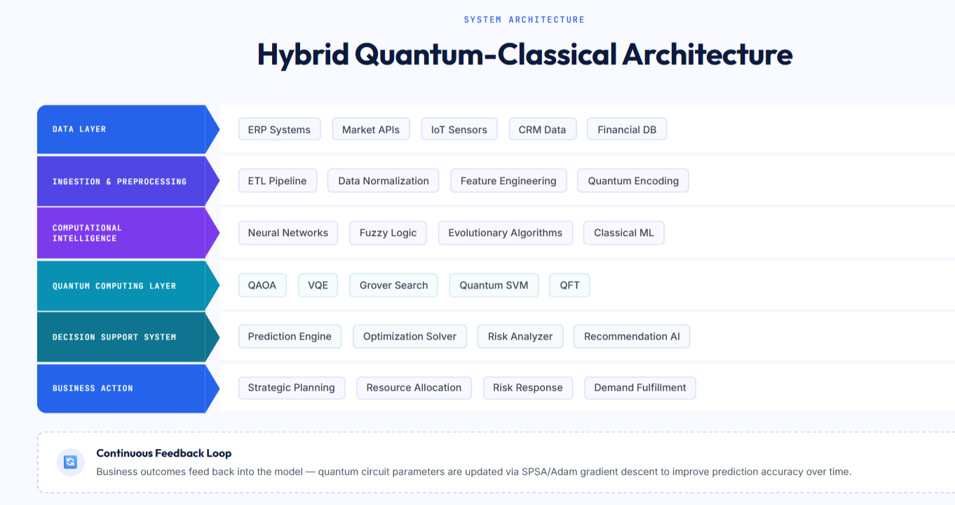
Fig. 1. Hybrid quantum-classical architecture showing the Quantum Computing Layer and its connection to computational intelligence and decision support.
IV-A. Data Collection
The process starts with both unstructured business data. Possible sources are transaction records, sales histories, inventory levels, market indicators, customer interactions, supplier information, operational logs and financial statements. The data source should be chosen based on the decision problem not on whether a quantum algorithm's available.
IV-B. Data Preprocessing
Preprocessing means cleaning up values removing duplicates finding outliers normalising numerical variables and turning categorical variables into numbers. Time-based data may need to be split to avoid leaking information. This step also sets the limits for the decision. Good preprocessing is vital because quantum processing cannot fix data.
IV-C. Feature Selection and Encoding
Feature selection cuts down the amount of variables that a quantum circuit must show and can make results easier to understand. Encoding then turns the chosen variables into a form that fits a circuit. Angle encoding is nice for demos because normalised numbers can be turned into rotation angles. Amplitude encoding can pack vectors nicely in theory. It can add a lot of work to prepare the state. The framework therefore says to compare the cost of encoding and the quality of the quantum model of assuming that one encoding is always best.
IV-D. QUANTUM COMPUTING LAYER
The quantum computing layer is the dedicated quantum-processing stage of the proposed hybrid architecture. It is positioned after computational intelligence and quantum encoding and before the decision-support system. The layer receives prepared quantum data and applies a selected quantum algorithm according to the business problem. In the proposed architecture, QAOA, VQE, Grover Search, Quantum SVM and QFT are identified as representative quantum methods. QAOA is suitable for optimization-oriented decision problems, VQE represents a variational quantum approach, Grover Search represents quantum search, Quantum SVM represents a quantum classification approach, and QFT represents a quantum transformation used in appropriate quantum-processing tasks.
The quantum computing layer does not replace the classical part of the system. Instead, it works as a computational component inside the hybrid workflow. Quantum measurements or computed outputs are returned to the classical side, where they can be combined with predictions, constraints, business rules and other decision information. This allows the decision-support system to use quantum processing while retaining classical preprocessing, analytics, visualization and reporting.
In the project prototype, this layer connects the quantum algorithms shown in the architecture to the later prediction engine, optimization solver, risk analyzer and recommendation functions. The architecture therefore treats quantum computing as an integrated layer that contributes selected computational operations to the business decision process rather than as an isolated quantum experiment.
IV-E. AI/ML and Quantum Algorithm Selection
The fourth step selects an approach. Classical models such, as linear regression, logistic regression, random forests, gradient boosting, and neural networks are still the baseline. Quantum options might be kernels, variational quantum classifiers, quantum neural networks, QAOA or other variational circuits depending on the job. The chosen method should be justified by the way the problem is set up. Compared to a model.
IV-F. Quantum Processing
In this step, the quantum part runs the chosen circuit on a simulator or a quantum processor. Multiple measurements are taken to estimate output probabilities or expectation values. When using hardware, steps such as error handling and making the circuit shorter might be needed. The results from the measurements are sent back to the workflow for checking and more improvements.
IV-G. Optimization
Prediction gives business estimates such as demand levels, risk exposure, the chance a customer will respond or expected results. Optimisation then takes those estimates. It adds limits to find an action. A mixed workflow can use a model in one part and a traditional optimiser in another. It can also use a quantum optimisation method directly on the decision problem.
IV-H. Business Recommendation
The output needs to be changed into a business suggestion. Examples include choosing how to distribute a portfolio planning production schedules, picking suppliers, setting inventory rules or assigning people. It should contain information related to uncertainty and should indicate which limitations were considered and assumptions made by the model. The responsible persons should still apply business judgment, corporate policies, and their industry experience.
IV-I. Model Improvement
This final step closes the cycle. Actual business performance is compared with the forecast and recommendations. Depending on this comparison, the model could be retrained, tuned, and optimised. Such a feedback mechanism is important since the business environment evolves in time. It also allows checking the relevance of the quantum component.
VI. BUSINESS APPLICATIONS
5.1 Financial Forecasting. Financial forecasting includes prediction of prices, demand, return, volatility, or other indicators based on some data. Quantum-enhanced approaches may include combinations of time series or machine learning models with feature maps or variational circuits. Quantum finance research suggests simulation, optimisation, and machine learning as application domains [6].
5.2 Risk Management. Risk management often involves evaluating scenarios and estimating the probability or consequence of negative outcomes. Algorithms in quantum computing for verification or measurement of variables have received a lot of attention owing to their advantages. However, such advantages are based on various factors like the manner in which data is pre-processed, the structure of the circuit used, the noise and the computation effort involved in making measurements. It is possible to design an enterprise architecture with traditional risk model generating scenarios and quantum calculations.
5.3 Supply-Chain Optimisation. Supply chain management has decision-making processes for routing, scheduling, inventory, suppliers, and facility locations. These decision-making processes become very complex with multiple locations, products, transportation vehicles, periods of time, and constraints. Quantum optimisation algorithms are applicable in certain areas, particularly with binary decisions. The best solution will be an optimisation algorithm that follows the constraints.
5.4 Resource Allocation. Resource allocation decides how limited resources—like money, people, machines, power or computer power—should be shared between tasks. The problem can be set up as an optimisation goal that balances cost, space, quality of service and expected return. QAOA or similar methods can be tried as solutions, with integer programming and other methods used as tests to compare.
5.5 Strategic Planning. Strategic planning brings together prediction and optimization. Companies might look at investments, products entering new markets or adopting new technology under different conditions. Quantum computing can help as a tool that looks at situations or problems that need optimization. The final recommendation should include results from models along with the opinions of managers and the rules that guide the business.
5.6 Business Intelligence and Predictive Analytics. Business-intelligence systems take data from operations and turn it into dashboards, predictions, warnings and suggestions. Quantum machine learning can be used in some jobs while traditional methods continue to manage grouping data showing it visually making reports and handling many regular machine-learning tasks. This mix is better than thinking that quantum computing can replace all parts of the business-intelligence system.
VII. EVALUATION METHODOLOGY
Because this paper is a study about a framework based on the project summary the evaluation is described as a method that can be repeated of as made-up results from experiments. Any version of the system that is built should check the quantum-enhanced process against the traditional methods using the same data rules for making decisions and ways to measure success.
6.1 Experimental Design. A good test should start by choosing one business issue like managing a group of investments predicting how much people will want a product or deciding how to move goods. The data should be split into parts for training, checking and testing when needed. The quantum model should use the goal as the traditional method. Tests should be done again with the random starting points and if there is enough data the chances of error should be shared.
6.2 Performance Metrics. For predictions and estimating numbers good measures are mean error (MAE) root mean square error (RMSE) mean absolute percentage error (MAPE) and R squared. For classifying things measures like accuracy how often a prediction is correct how often a correct prediction is made how often a thing is found the F1 score and the area under the receiver operating characteristic curve can be used. For finding the solution the value of the solution how often rules are broken how close the solution is to the best and how long it takes are important. At the level of business decisions the important measures might be the amount of money saved how much income is changed, the level of service how well resources are used or the return on investment after considering the risk.
6.3 Classical Baselines. A quantum method should not be tested alone. For predicting jobs traditional options could be regression, support-vector machines, random forests, gradient boosting or neural networks. For finding the solution options might include mixed-integer programming, dynamic programming, simple ways to find a good answer methods that try many options or well-known tools for solving problems. The traditional method should be strong enough to show if any improvement is real.
6.4 Quantum-Specific Measurements. Quantum tests should share the number of qubits, how complex the instructionsre how many parts can be changed how many times the test is run what kind of computer or machine is used and any way to reduce mistakes. These details are important because an algorithm might look good on paper but cost much to use in real life.
6.5 Decision-Level Evaluation. The important test should be about the business decision. A little better in a prediction measure is not helpful if it does not make the final business result better. So the framework says to report both the technical measures and the business results like total cost, profit, risk how well resources are used the level of service or how quickly a decision is made.
VIII. DISCUSSION
7.1 Expected Benefits. The main advantage of the method suggested is the chance to use kinds of computing tools for difficult business problems. Quantum machine learning can create ways to look at data and models that can learn while quantum optimization can offer different ways to solve business problems. Hybrid setups also let companies keep the ways that work while trying new quantum parts.
A second advantage is the chance to bring prediction and solving problems together. Of just making a forecast and letting a separate person or tool decide what to do the framework links the prediction part with the part that makes decisions while following the rules. This is very important, in finance moving goods running a business and planning resources.
7.2 Hardware and Noise Constraints. Current quantum processors have a lot of noise. Are limited by the number of qubits how they connect, how long they stay stable and how deep the circuits can be. These problems can make the performance of algorithms that look good on paper not work well in life. Variational methods were partly created because of these near-term problems. They still have issues like how much it costs to measure how easy they are to train and how sensitive they are to noise [3].
7.3 Data Loading and Encoding Cost. Business datasets are usually data. So the cost of changing data into a form must be part of any full comparison. Feature selection and reducing the number of dimensions can be helpful not only for machine learning but also for making the quantum circuits simpler.
7.4 Scalability and Cost. Making a small prototype work for a business system can add a lot of costs. Cloud access, running the circuits many times in loops for classical optimisation, and fixing errors can all take more time. The time taken by the quantum element should not be the only focus when examining the system’s total cost of ownership.
7.5 Explainability and Human Oversight. Often, business decisions require explanations from the perspective of management, customers, auditors, and regulators. Quantum models are less explainable than classical models since they may allow a wide variety of encodings and layerings. The framework thus puts the recommendation into a classical layer of decision where rules, assumptions, uncertainty, and business logic can be explained.
7.6 Security, Privacy, and Governance. Business data can contain financial, customer, operational, or strategic data. A quantum system should comply with all the rules applicable to data as a regular system in terms of access rights, secure transfer, data retention, and privacy. Quantum computing does not provide a business application with automatic security and privacy.
IX. FUTURE SCOPE
Further research can advance from formulating the theoretical background and developing practical models for various application domains. For instance, the first research can address the solution to a certain business challenge, such as portfolio optimisation or supply chain scheduling, and compare QAOA or some other algorithm with conventional optimisation techniques. The next direction is the testing of QML algorithms on a suitable business dataset to assess their predictive power, robustness, and computational costs.
With the further development of quantum technology, including increased size of circuitry and improved measurement accuracy, it becomes possible to investigate larger datasets and more complex hybrid models. However, hardware advances are not sufficient by themselves. Algorithm development, data encoding, testing, and measurement approaches should be improved. Real quantum advantage needs comparisons and finding the right problems for quantum methods [5].
Another path is to think about than one goal at a time. Real business choices often try to balance than one thing. Supply chains might balance service level with cost and finance might balance return with risk. Quantum optimization is looking more at these kinds of choices making this a good path for business-focused quantum help.
Finally future systems can use feedback from business results. This can let models be retrained, monitored, have rules and check if the quantum part still helps. A full life cycle is needed to move from a model to a real decision-making system.
X. CONCLUSION
This paper presented a research framework for using quantum computing to improve how businesses make decisions. The framework matches the project abstract given. It brings together data analysis, artificial intelligence and machine learning with some quantum algorithms in a full business process.
The process starts with collecting and preparing data then choosing features and turning data into quantum form. It combines AI/ML with a quantum algorithm does quantum work and changes the results into predictions, optimization and business advice. A feedback step helps improve the model when new data comes in. The study found areas like financial forecasting, managing risk making supply chains better using resources well planning strategy as well as the collection of business information. The prospects for QML and hybrid variational methods seem to be promising, while quantum optimization seems to be highly valuable for decision-making with a number of constraints and options.
As mentioned in the article at the time when it was written, quantum computing cannot fully substitute classical computers. High noise, expensive devices, costly process of encoding information in quantum state and scaling, as well as lack of qualified experts in the field, are the problems that remain relevant. The most effective approach is to create systems that combine both and compare them with classical systems extensively.
V-A. Prototype Quantum AI Workflow
The proposed prototype describes the entire process in a linear form starting from traditional preprocessing and model training via AI/ML, followed by quantum algorithms and hybrid computing to achieve optimised business outputs.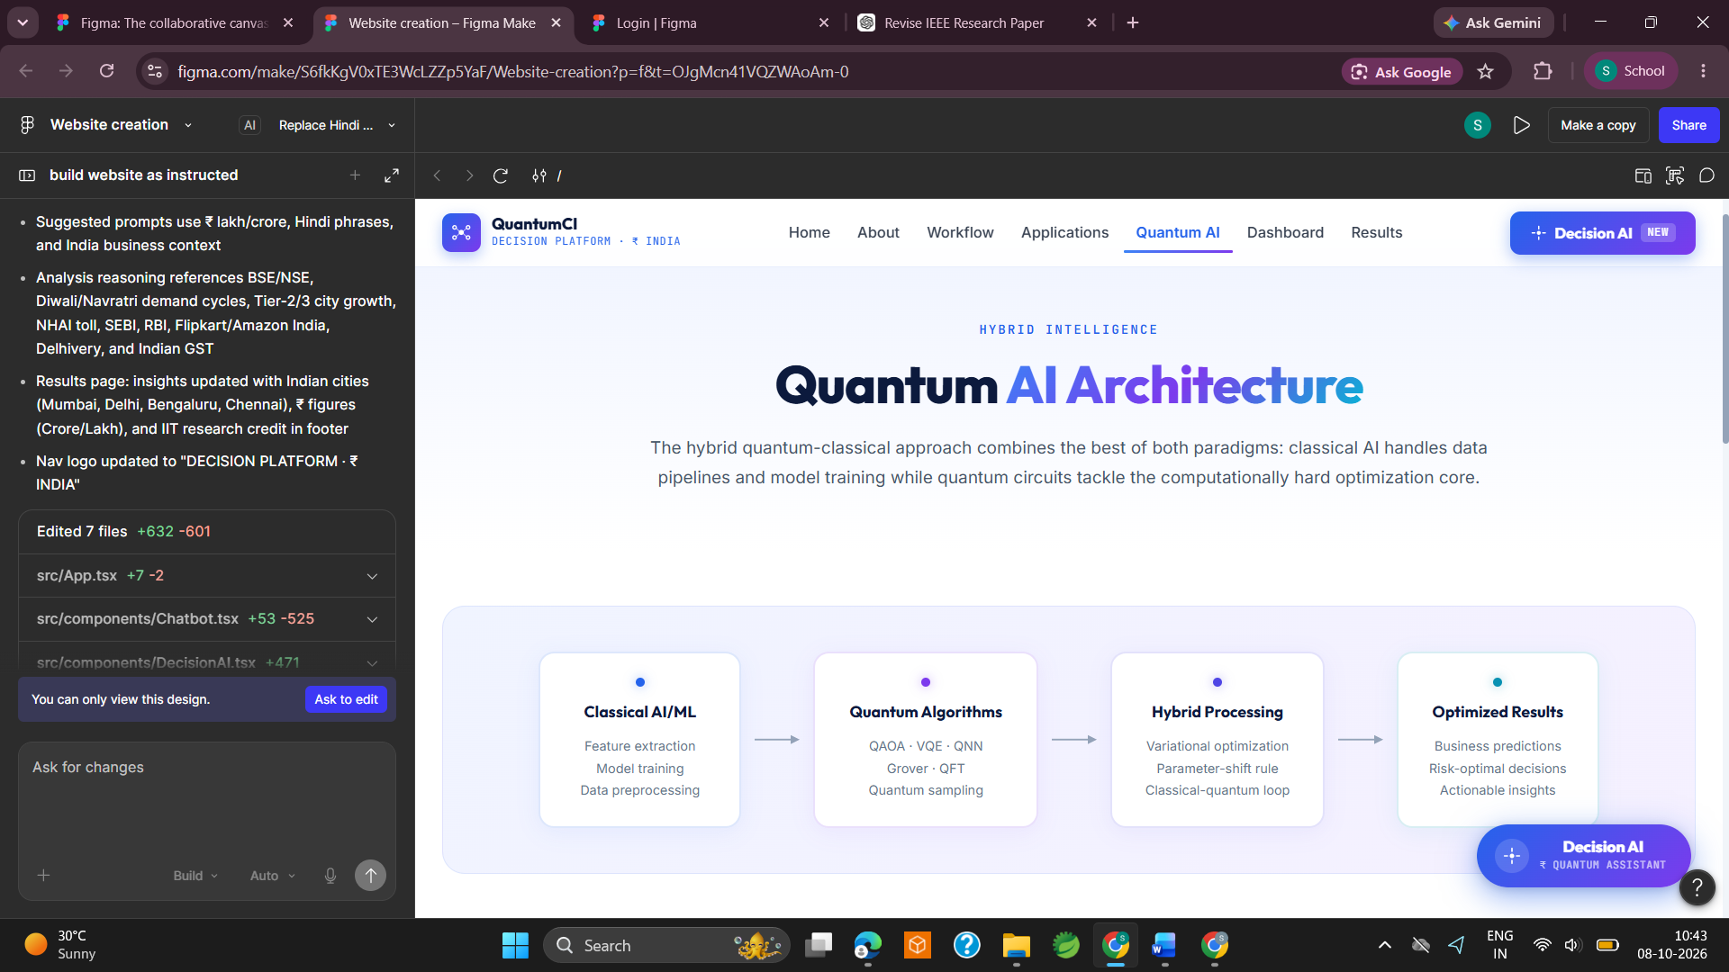
Fig. 2. Quantum AI Architecture page with classical AI/ML, quantum algorithms, hybrid computing, and optimised results.
VI-A. Prototype Business-Intelligence Decision Dashboard
The sample dashboard shows that it is possible to represent a business decision as a budget allocation problem, as well as QAOA as an optimisation technique. KPI values shown in the figures below are interface outputs, not experimental data.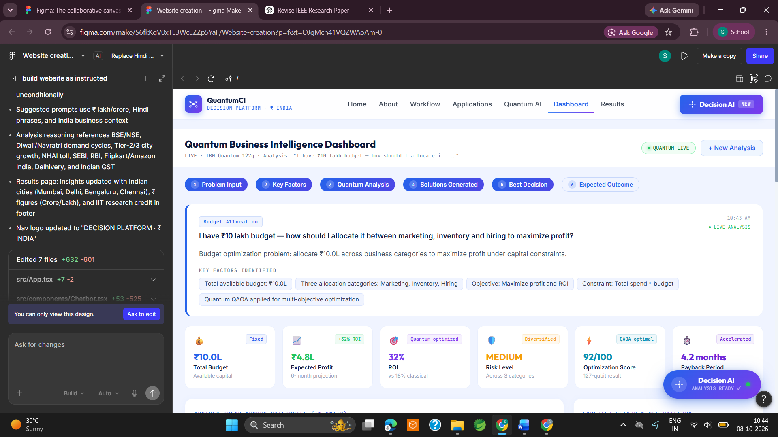
Fig. 3. Quantum Business Intelligence Dashboard illustrating the process of the budget-allocation decision making and sample decision metrics.
VI-B. Prototype Visual Analytics
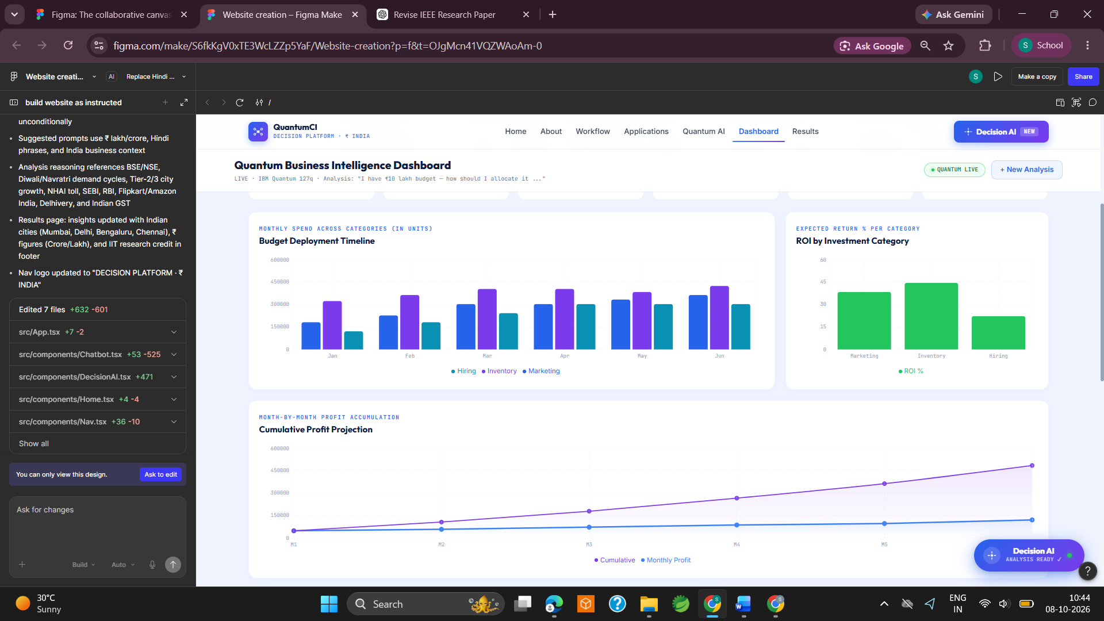
Figure 4. Visual analytics prototype illustrating the timeline of budget implementation, return on investment (ROI) from investments in categories, and total profit forecast.
[16] "Applications of quantum computing to businesses: An approach using B-SLR model and future research," EPJ Quantum Technology, 2026.
[15] S. Muzzioli et al., "Quantum computing in finance: A review and future directions of trustworthy financial AI," Frontiers in Artificial Intelligence, vol. 9, 2026.
[14] D. Herman et al., “A survey of quantum computing for finance,” arXiv:2201.02773, 2022.
[13] D. J. Egger et al., “Quantum computing for finance: State-of-the-art and future prospects,” IEEE Transactions on Quantum Engineering, 2020.
REFERENCES
[1] M. A. Nielsen and I. L. Chuang, Quantum Computation and Quantum Information, 10th Anniversary ed. Cambridge University Press, 2010.
[2] J. Biamonte, P. Wittek, N. Pancotti, P. Rebentrost, N. Wiebe and S. Lloyd, “Quantum machine learning,” Nature, vol. 549, pp. 195–202, 2017.
[3] M. Cerezo et al., “Variational quantum algorithms,” Nature Reviews Physics, vol. 3, pp. 625–644, 2021.
[4] E. Farhi, J. Goldstone and S. Gutmann, “A quantum approximate optimization algorithm,” arXiv:1411.4028, 2014.
[5] A. Abbas et al., “Challenges and opportunities in quantum optimization,” Nature Reviews Physics, vol. 6, pp. 718–735, 2024.
[6] D. J. Egger et al., “Quantum computing for finance: State-of-the-art and future prospects,” IEEE Transactions on Quantum Engineering, 2020.
[7] D. Peral-García, J. Cruz-Benito and F. J. García-Peñalvo, “Systematic literature review: Quantum machine learning and its applications,” Computer Science Review, 2024.
[8] J. Preskill, “Quantum computing in the NISQ era and beyond,” Quantum, vol. 2, p. 79, 2018.
[9] M. Schuld and N. Killoran, “Quantum machine learning in feature Hilbert spaces,” Physical Review Letters, vol. 122, 040504, 2019.
[10] P. Rebentrost, M. Mohseni and S. Lloyd, “Quantum support vector machine for data classification,” Physical Review Letters, vol. 113, no. 13, 130503, 2014.
[11] I. A. Prakash, “Quantum recommendation systems,” in Proc. 8th Innovations in Theoretical Computer Science Conference, 2017.
[12] G. Verdon et al., “Learning to learn with neural networks via classical neural networks,” arXiv:1907.05415, 2019.

